ReactJS Hands-On Lab Exercise Report
Cricket App – ES6 Features (map, arrow functions, destructuring, array merge)
Name: Rishi Gupta
Course: BridgeLabz SIPP Training 2026 – Week 6
Exercise: 9. ReactJS-HOL

Objective
The goal of this exercise was to build a small React application called "cricketapp" that demonstrates a set of ES6 features that we studied this week — the map() method, arrow functions, and array destructuring. The app needed two components, ListofPlayers and IndianPlayers, and both had to be shown on the same page using a simple flag variable and an if-else condition.

What I Did
I started by opening the project folder in VS Code and creating a fresh React app using create-react-app, inside the WEEK - 6/ReactJS-HOL folder that I already had set up for this week's work.
- Opened a PowerShell terminal in VS Code inside the ReactJS-HOL folder.
- Ran npx create-react-app cricketapp to scaffold the project.
- Moved into the cricketapp folder with cd cricketapp.
Below is the terminal output after the app was created successfully:
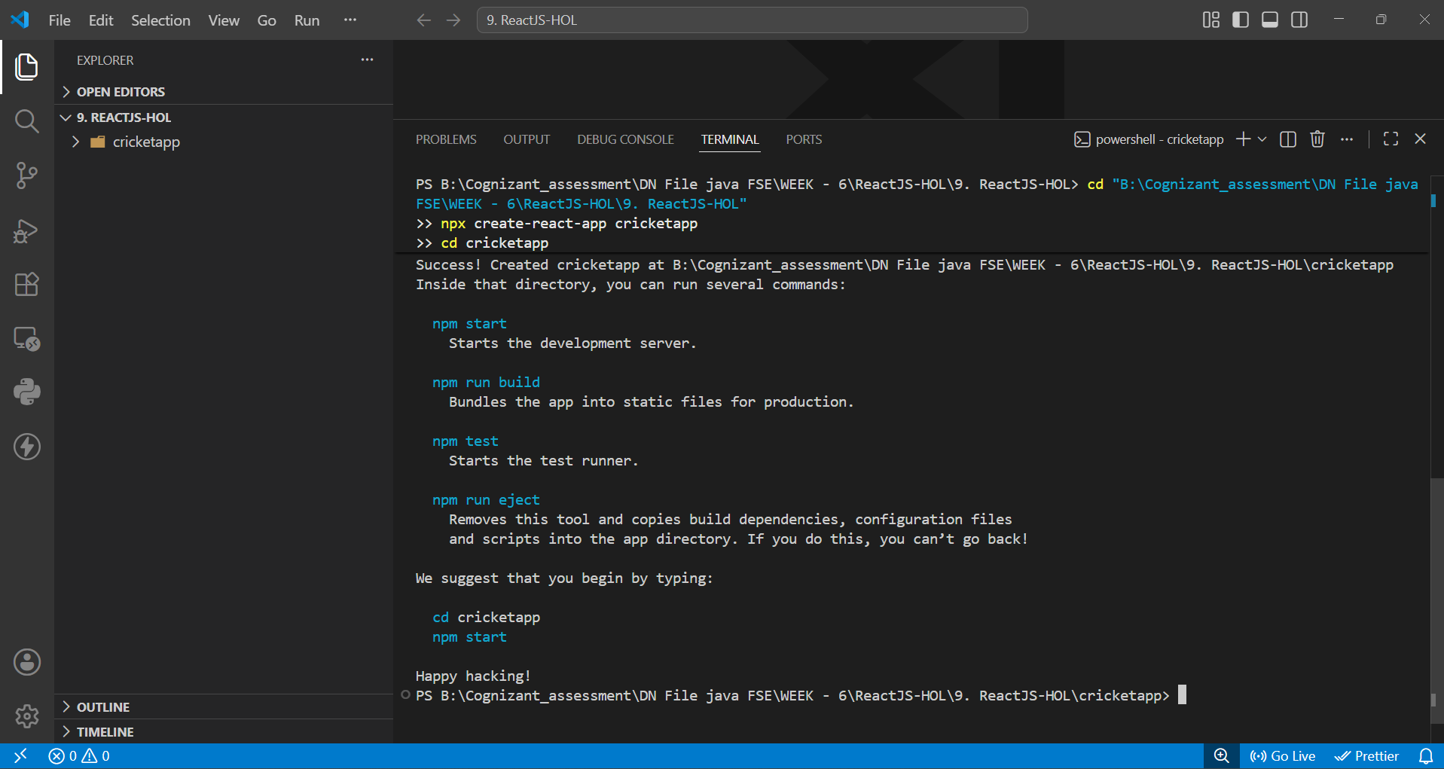
Fig 1: create-react-app finishing successfully inside the cricketapp folder

Building the components
Once the app was created, I added a components folder inside src and wrote two component files:
- ListofPlayers.js — declares an array of 11 players (name + score) and renders it using map(). It then uses an arrow function with filter() to pull out only the players scoring below 70, and renders that as a second list.
- IndianPlayers.js — uses array destructuring to split a players array into odd-position and even-position players, and separately merges two arrays (T20 players and Ranji Trophy players) using the ES6 spread operator.
In App.js, I set up a flag variable and used a ternary/if-else to switch between showing ListofPlayers or IndianPlayers on the home page, exactly as asked in the exercise.

Running the app
After writing the components, I ran npm start from the cricketapp folder to launch the dev server. It compiled without any errors, as shown below along with the App.js code where the flag decides which component gets rendered:
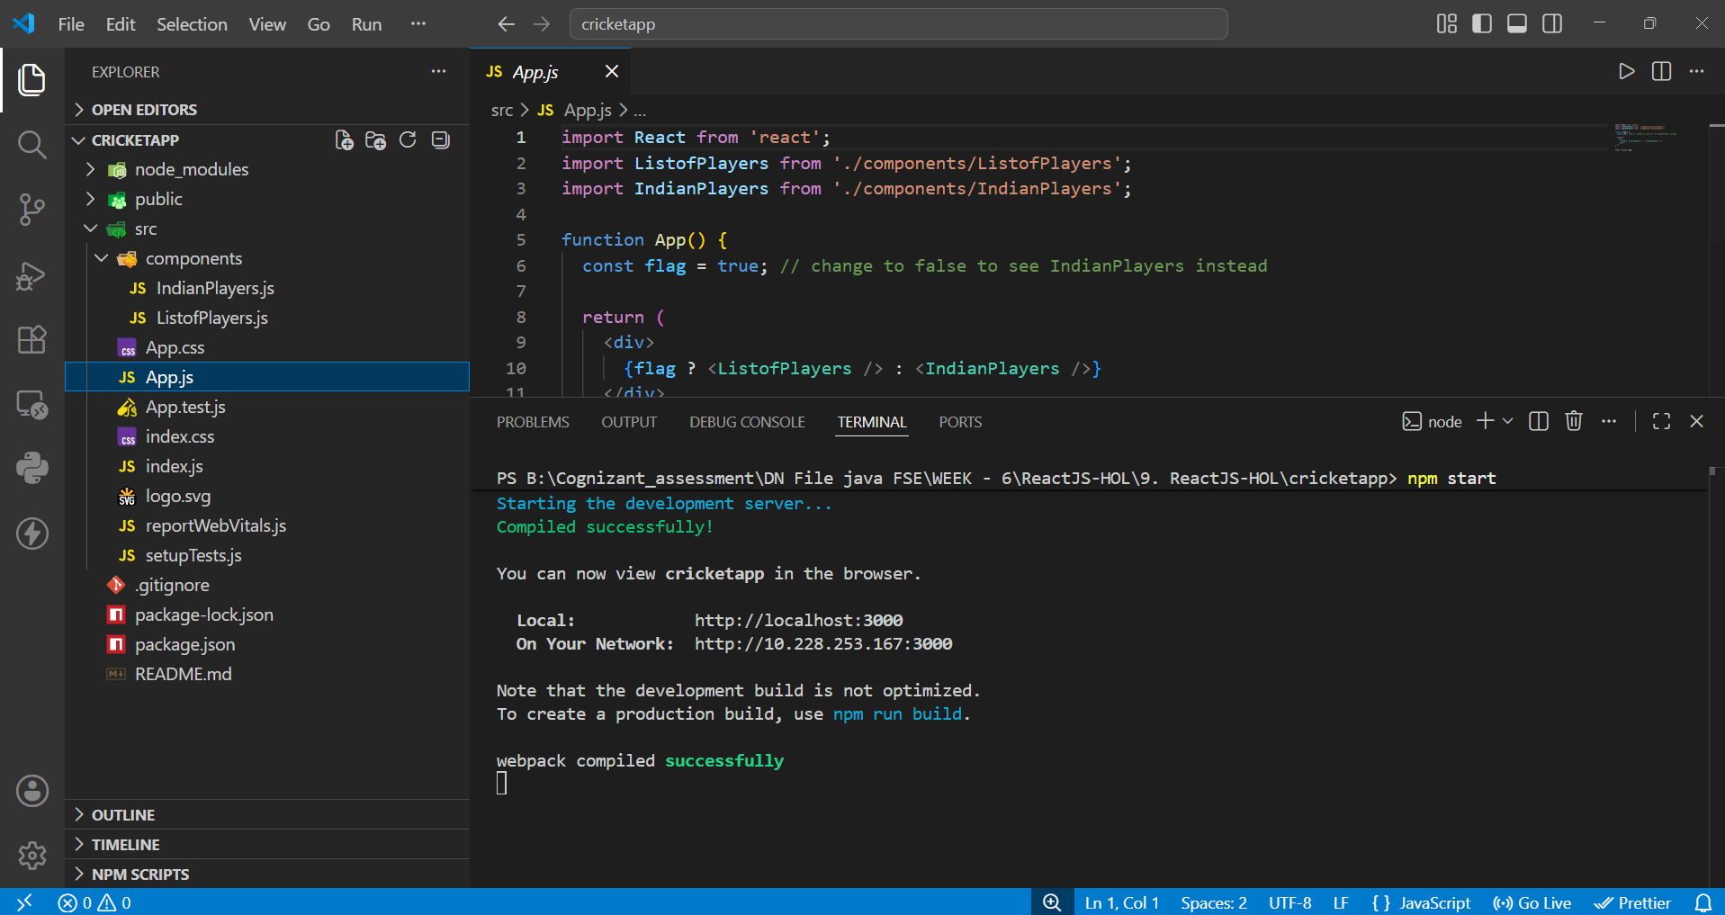
Fig 2: App.js with the flag-based conditional rendering, and npm start compiling successfully

Output
With flag set to true, the ListofPlayers component renders on screen. It shows the full list of 11 players with their scores, followed by a second list containing only the players whose score is below 70 — which matches the filter logic in the component.
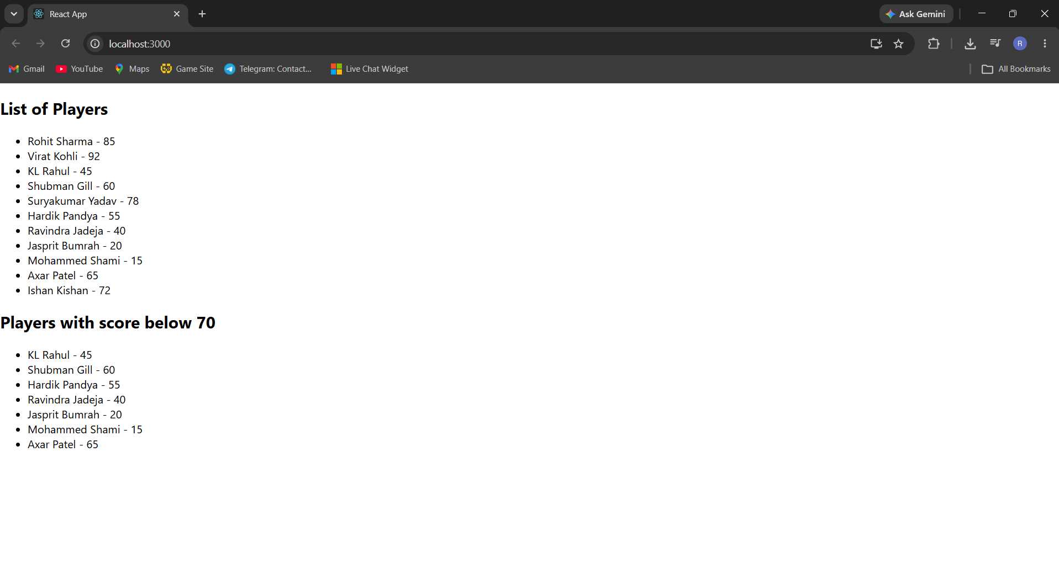
Fig 3: Browser output at localhost:3000 — List of Players and Players with score below 70

Observations
- map() made it straightforward to loop over the players array and render a <li> for each player without writing a manual for loop.
- Using an arrow function inside filter() kept the below-70 logic short and readable in one line.
- Array destructuring in IndianPlayers.js was a clean way to pull specific players out of an array by position instead of using index-based access everywhere.
- The spread operator made merging the T20 and Ranji Trophy arrays a one-liner, which was much simpler than using concat() or a loop.

Conclusion
This exercise helped me get comfortable with some of the core ES6 features used in everyday React development — map(), arrow functions, destructuring, and the spread operator for merging arrays. Toggling between the two components using a single flag variable also gave me a simple example of conditional rendering in React. The app compiled and ran correctly, and the output matched what was expected for the flag = true case.

